Name: Sakshi Sharma

1. Open Azure DevOps.

2. Create an Azure Virtual Machine (VM). You need to perform all the tasks within the VM.

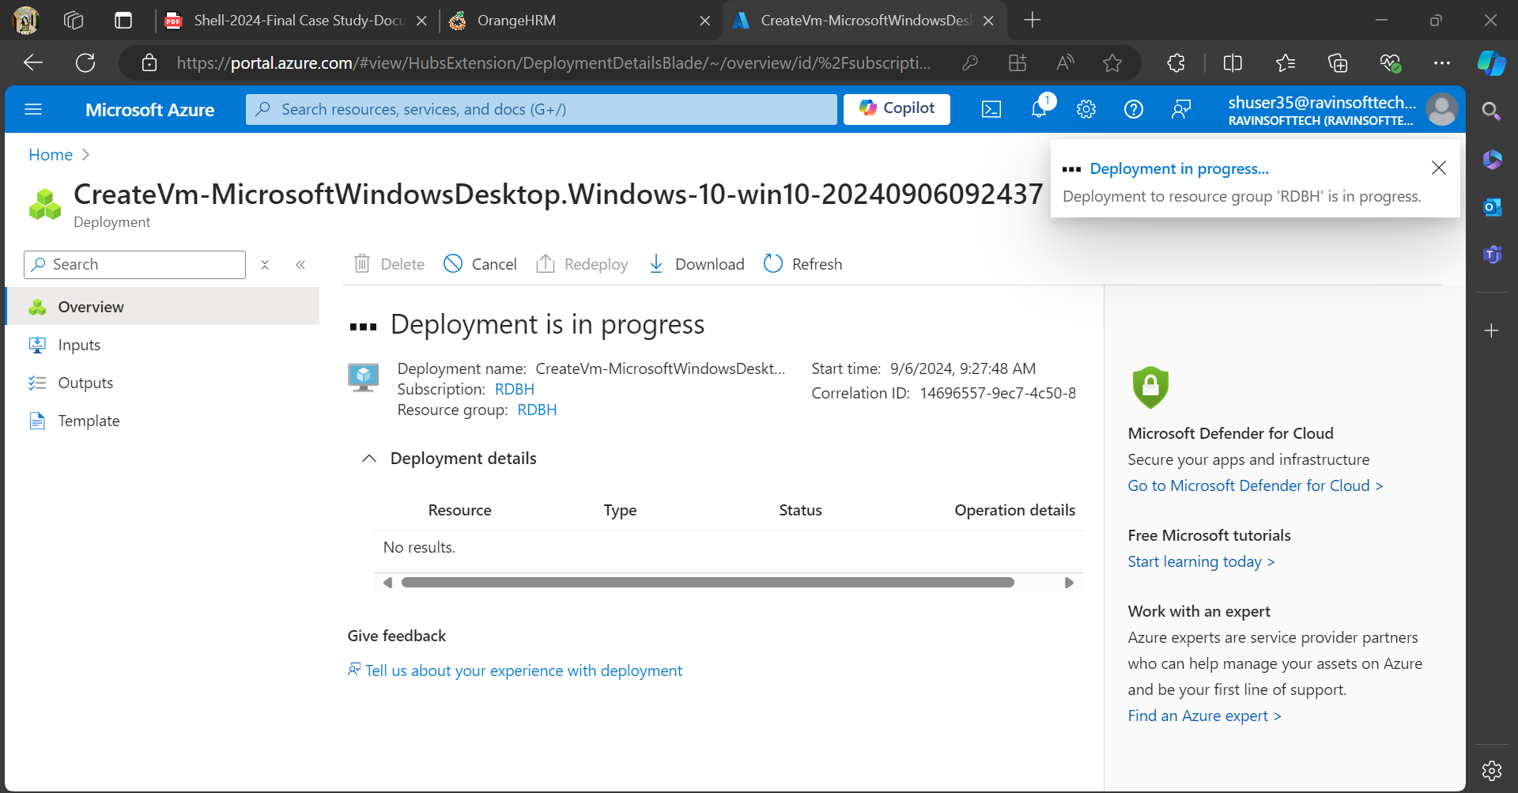

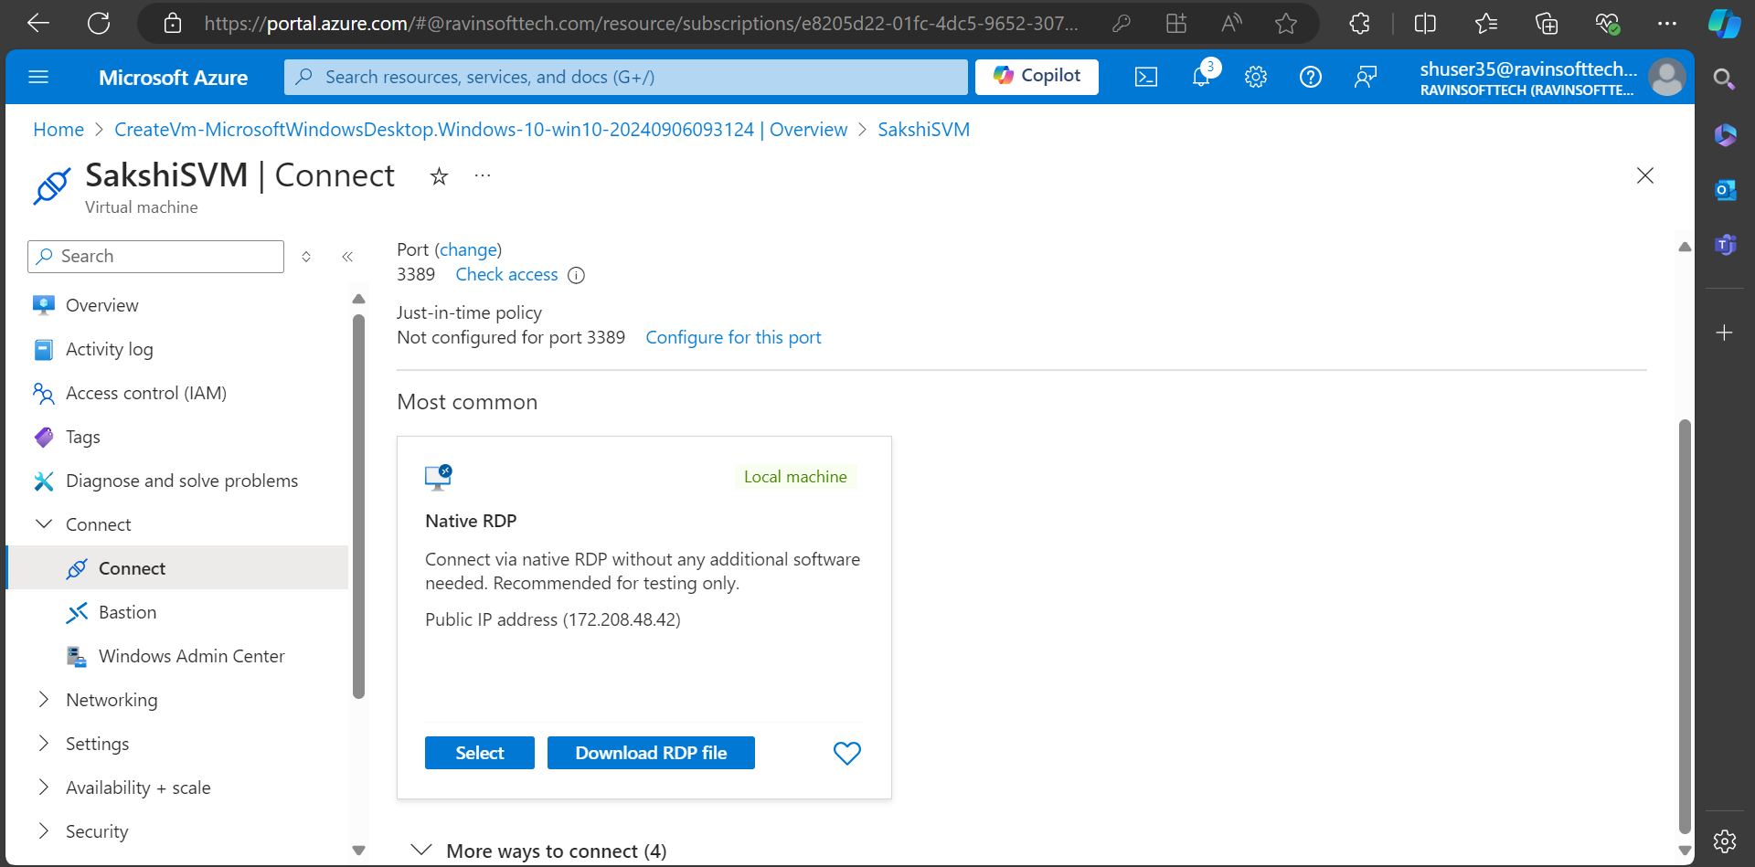

3. Login to the azure devops portal and navigate to the project

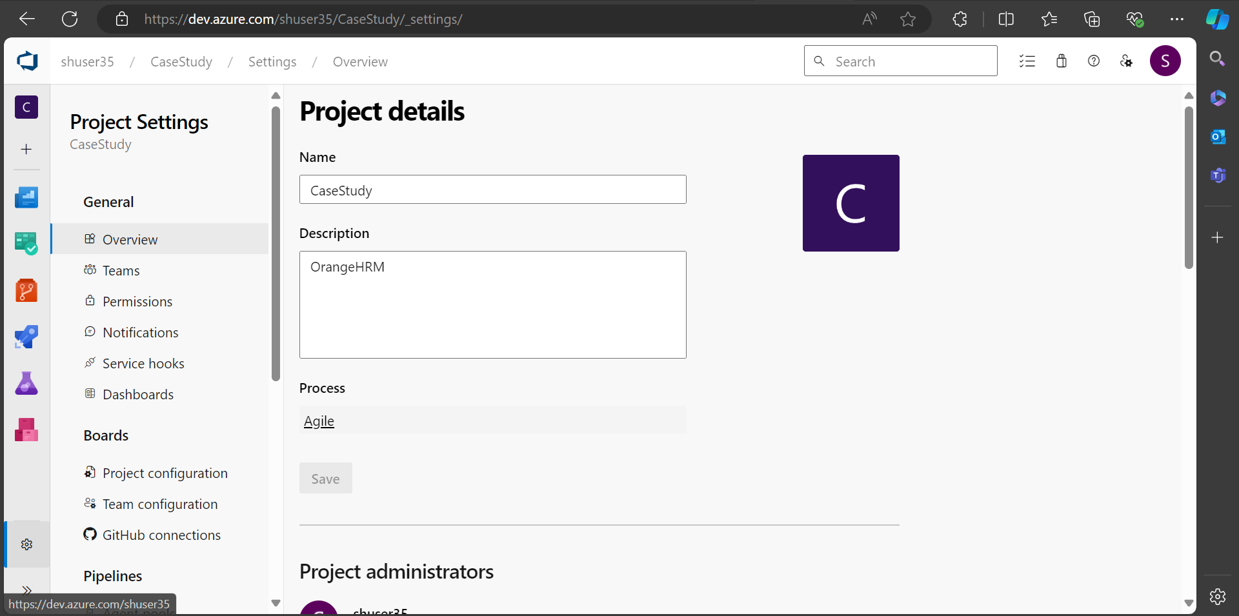

4.Create a New Sprint. Set the Sprint goals and objectives, aligning them with the overall testing strategy for the website.

5. Create 5 User Stories in the Sprint for the Sprint Backlog for the given application.

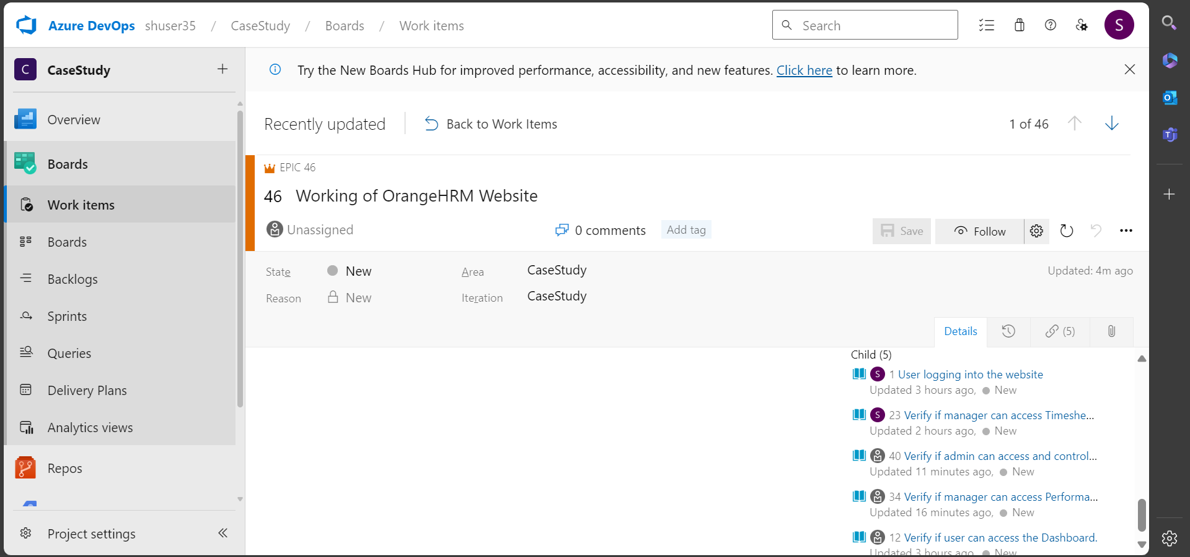

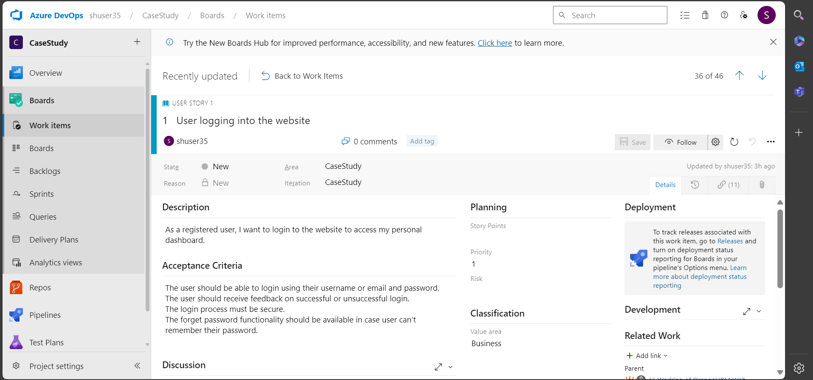

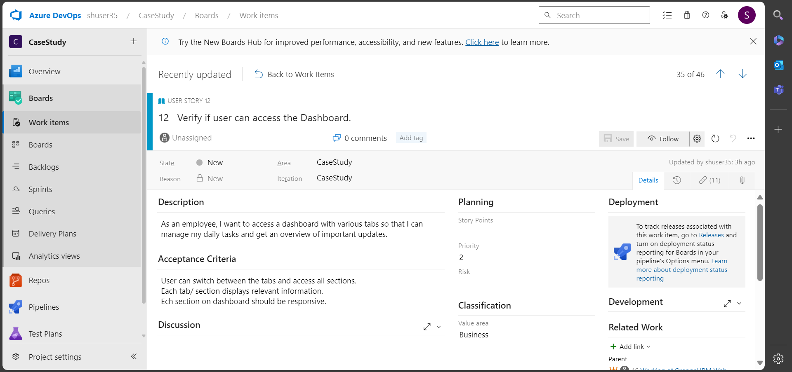

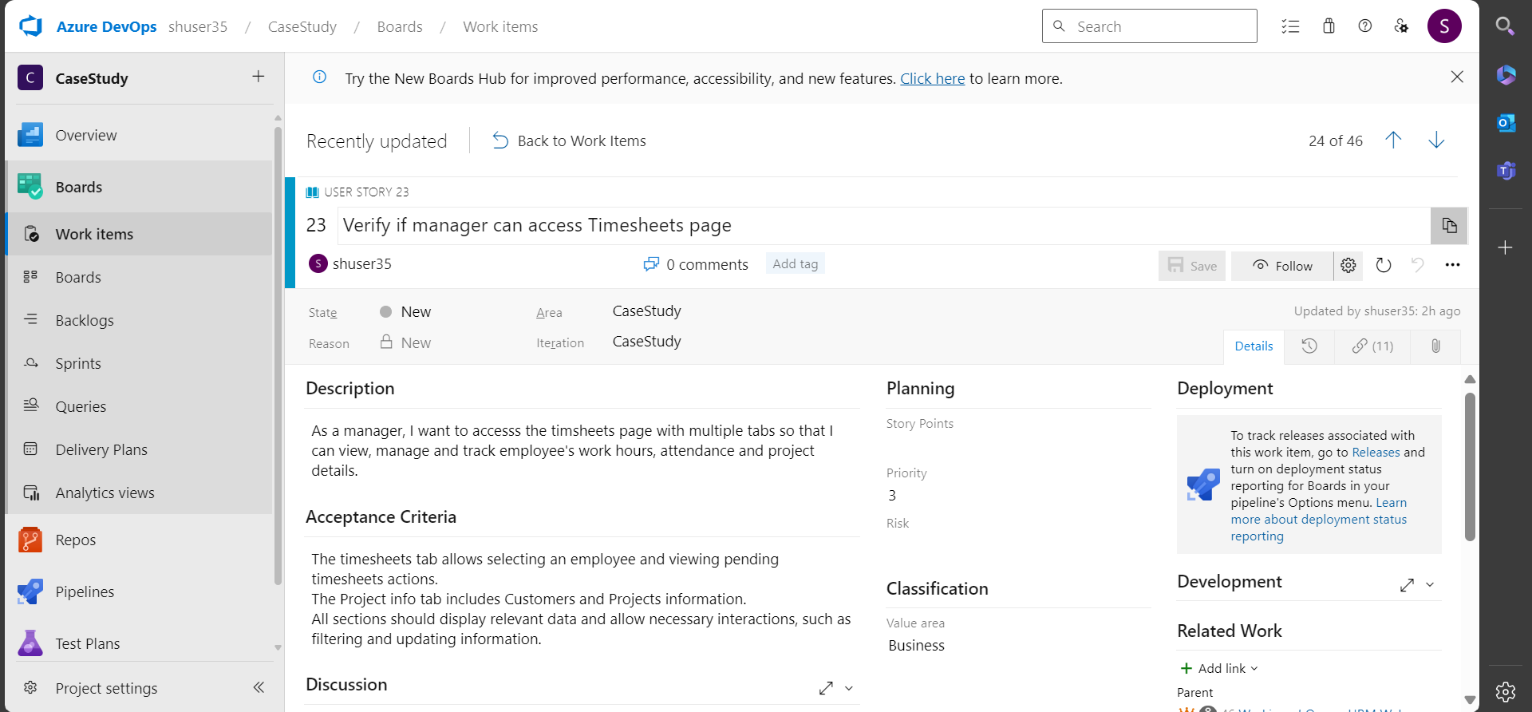

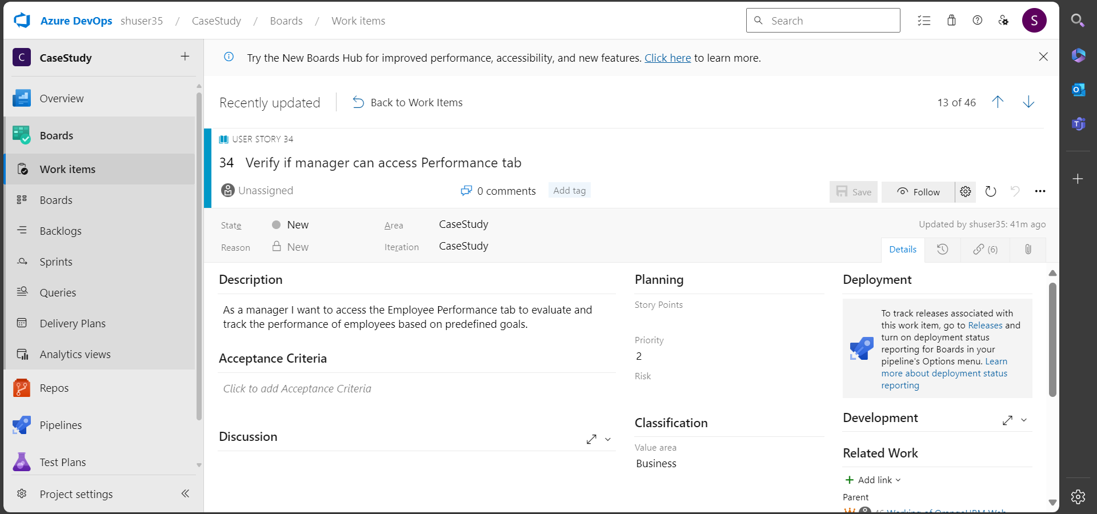

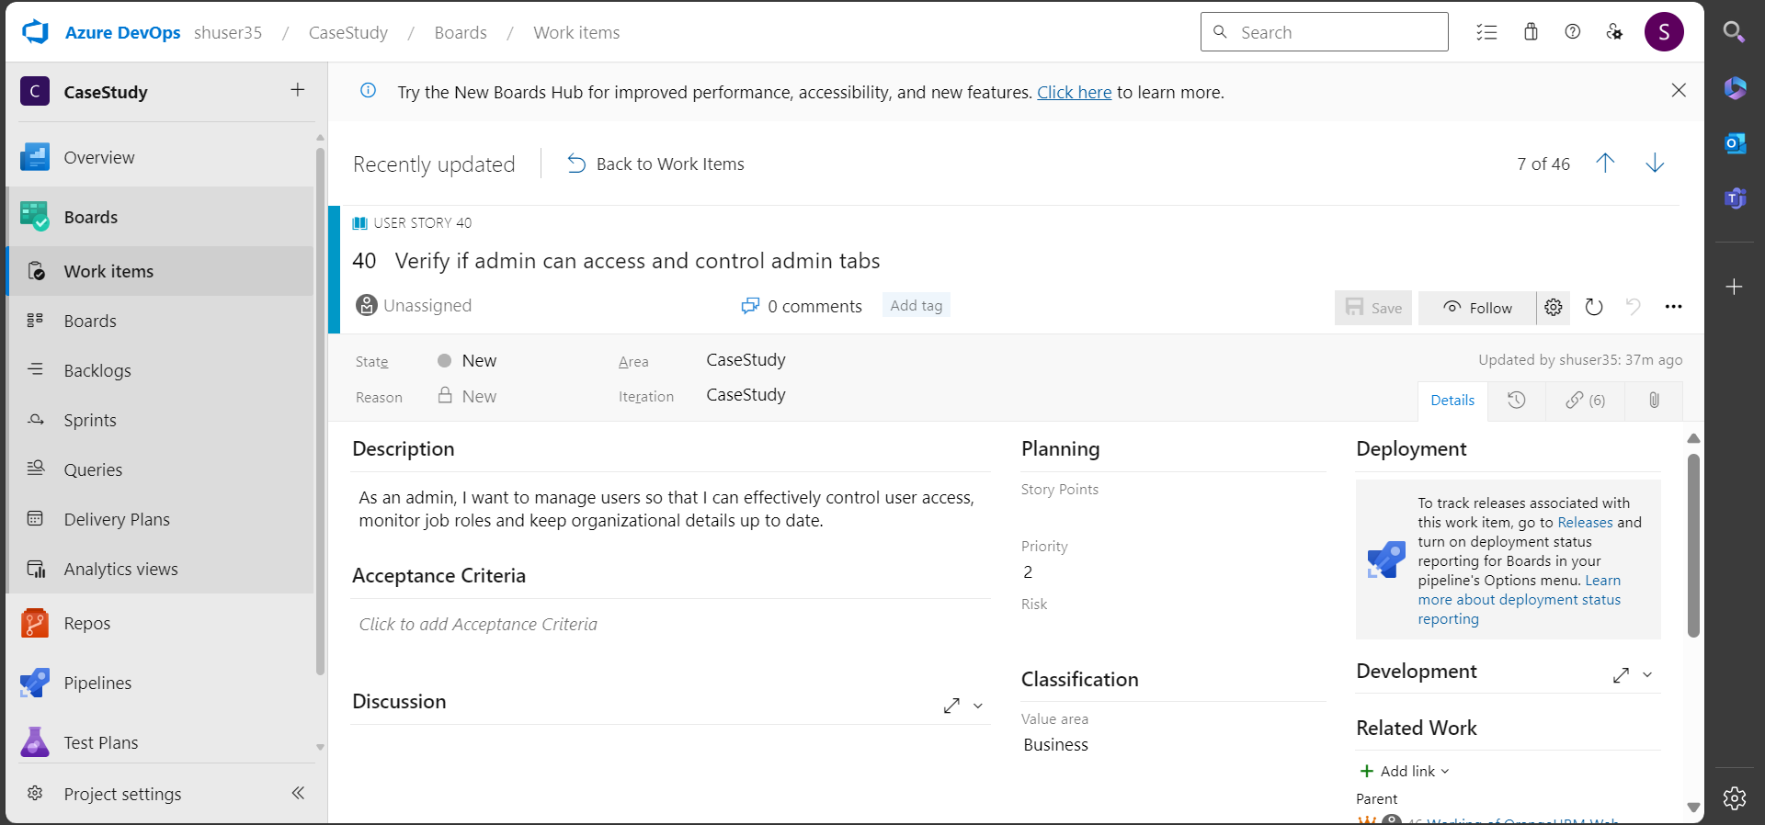

6. Each user story should cover different aspects of the Software Development Life Cycle (SDLC) as it relates to the functionalities of the website.

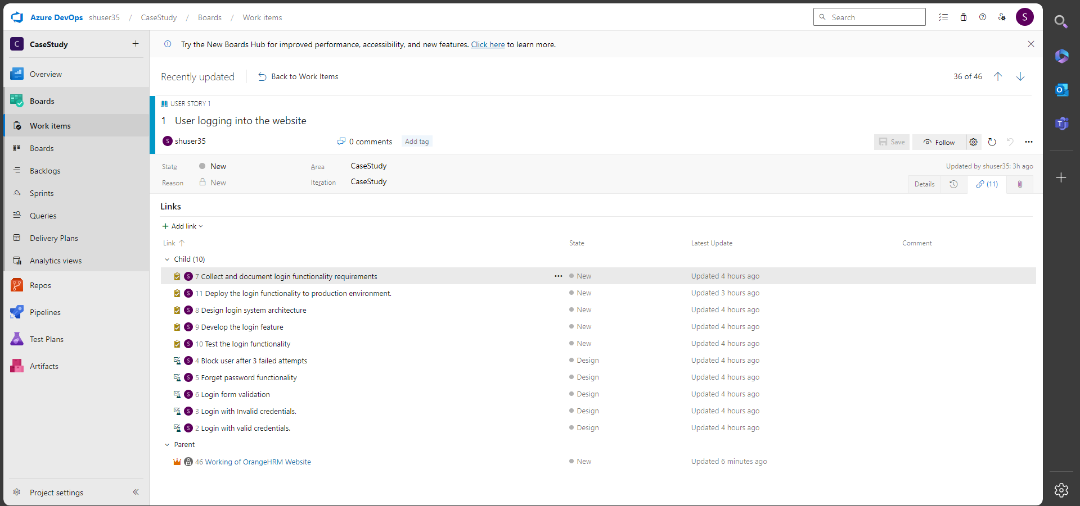

7. Create 25 test cases for the user stories created for the Sprint.

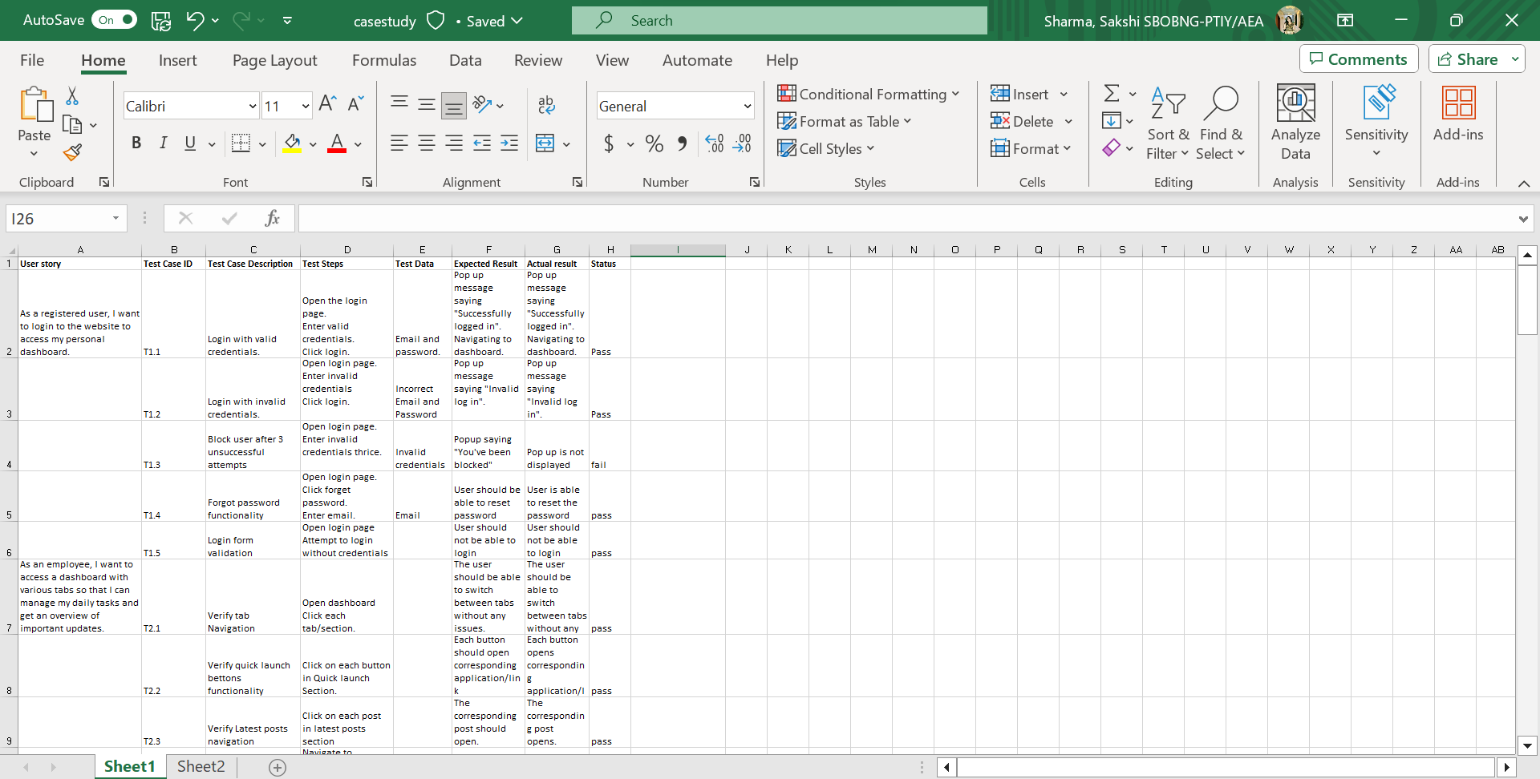

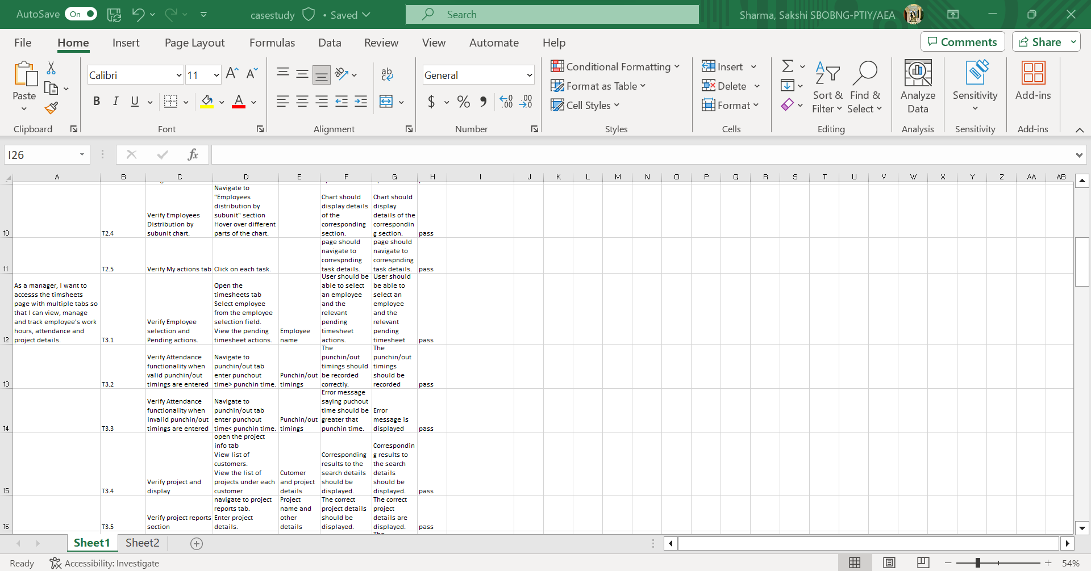

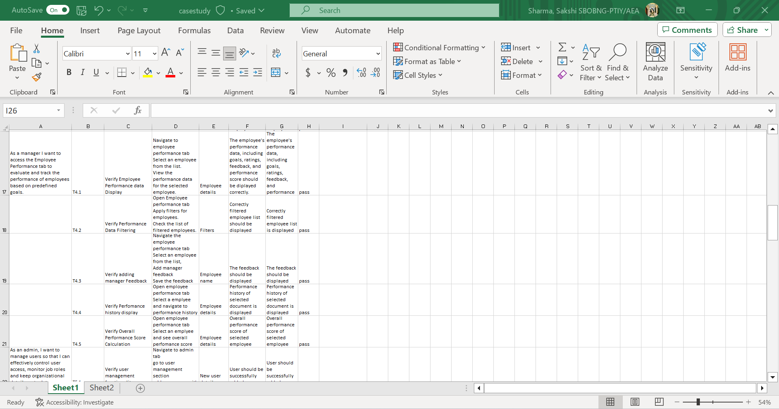

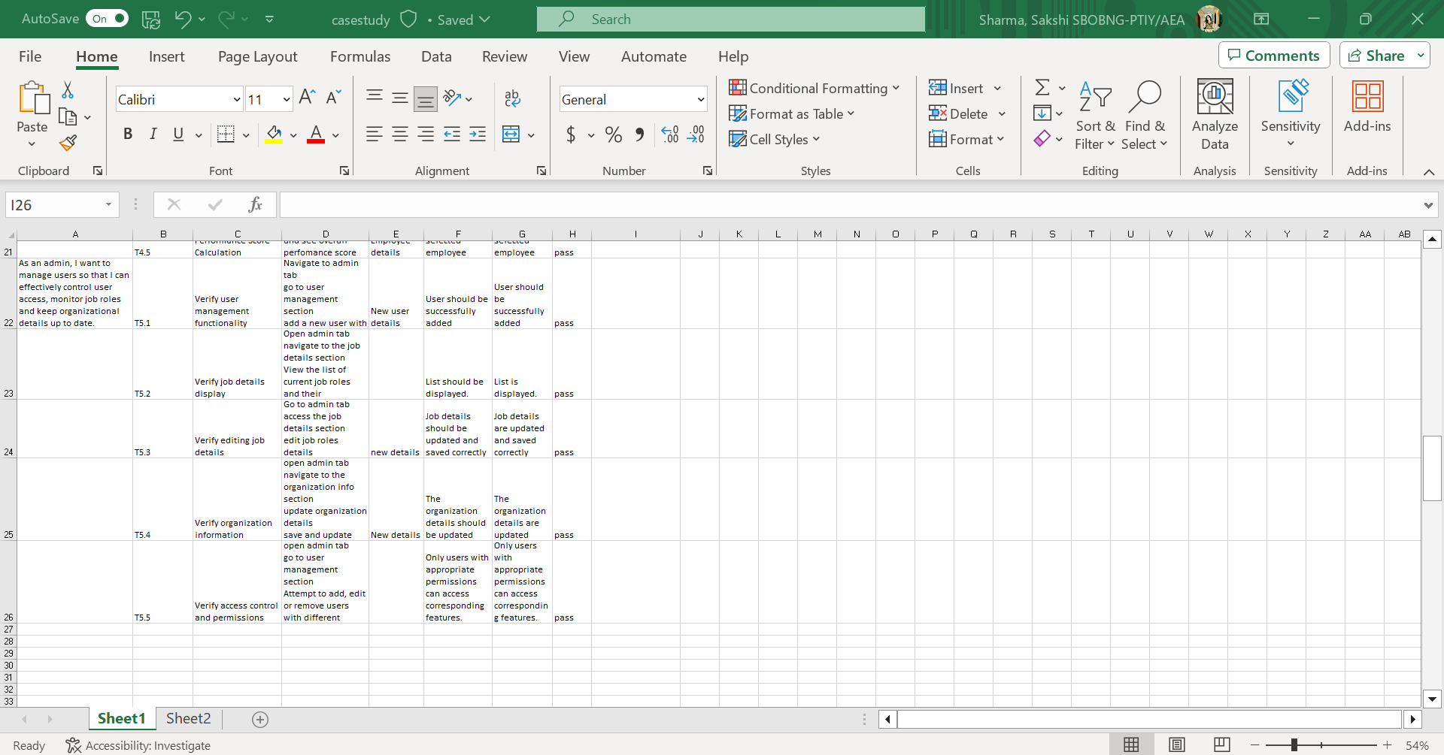

8. Define the tasks and sub tasks for each User Story.

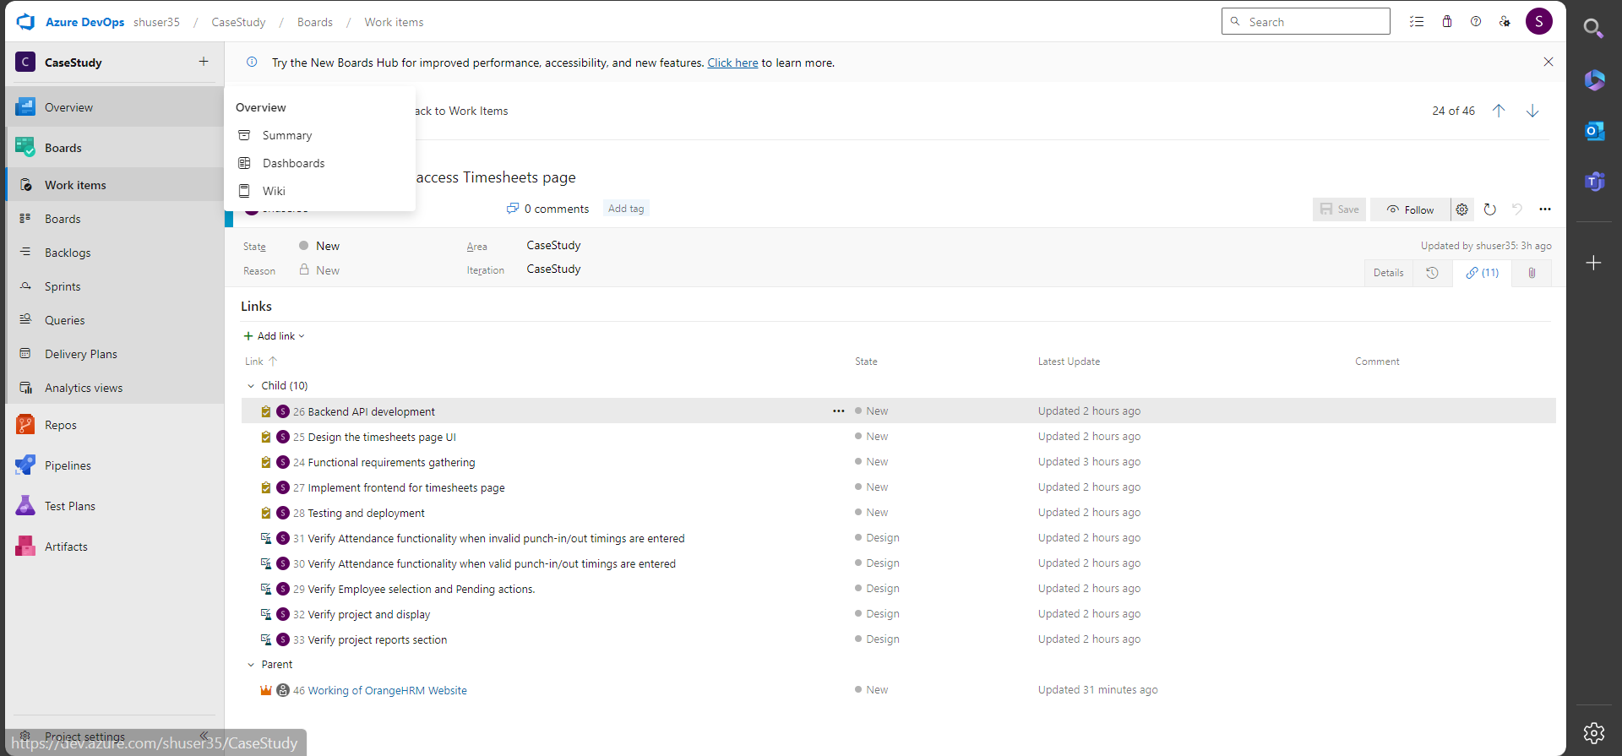

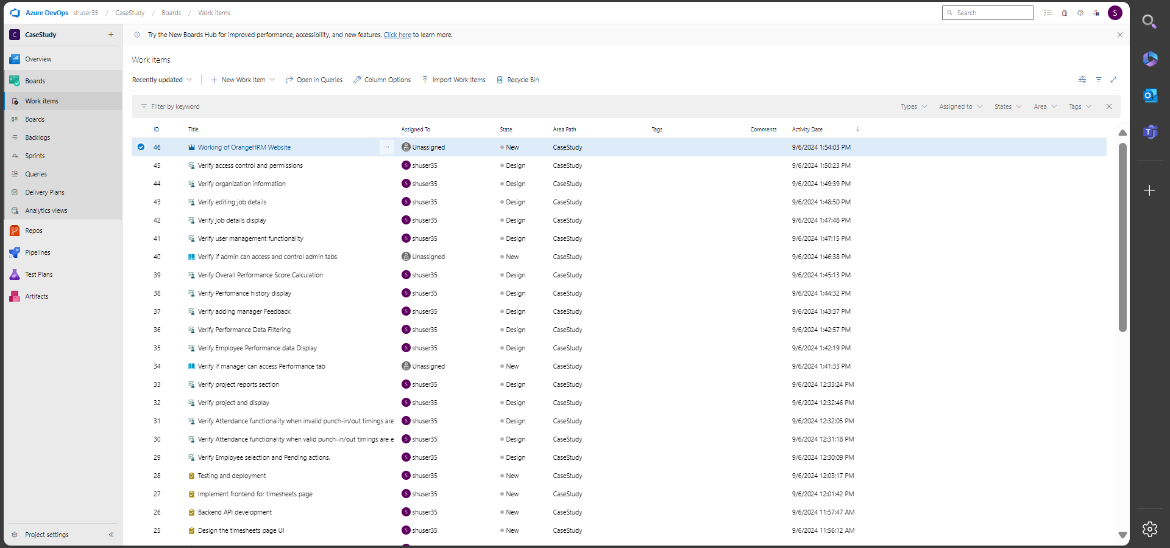

9. Execute all the test cases manually (functional testing).

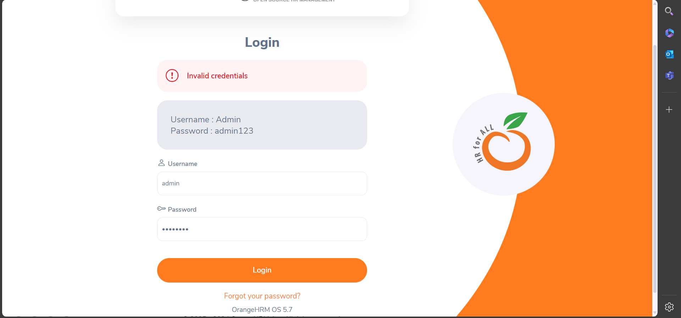

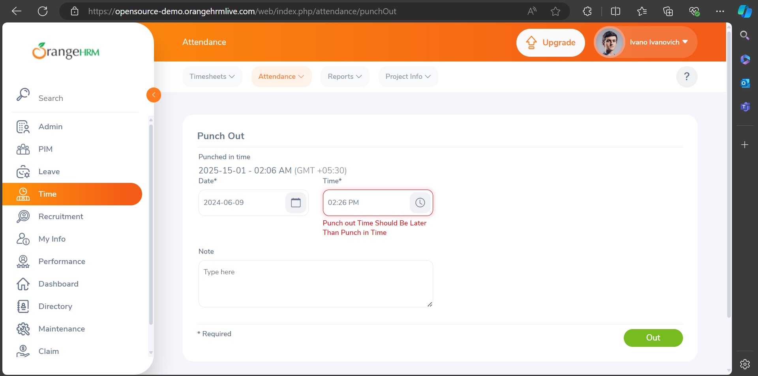

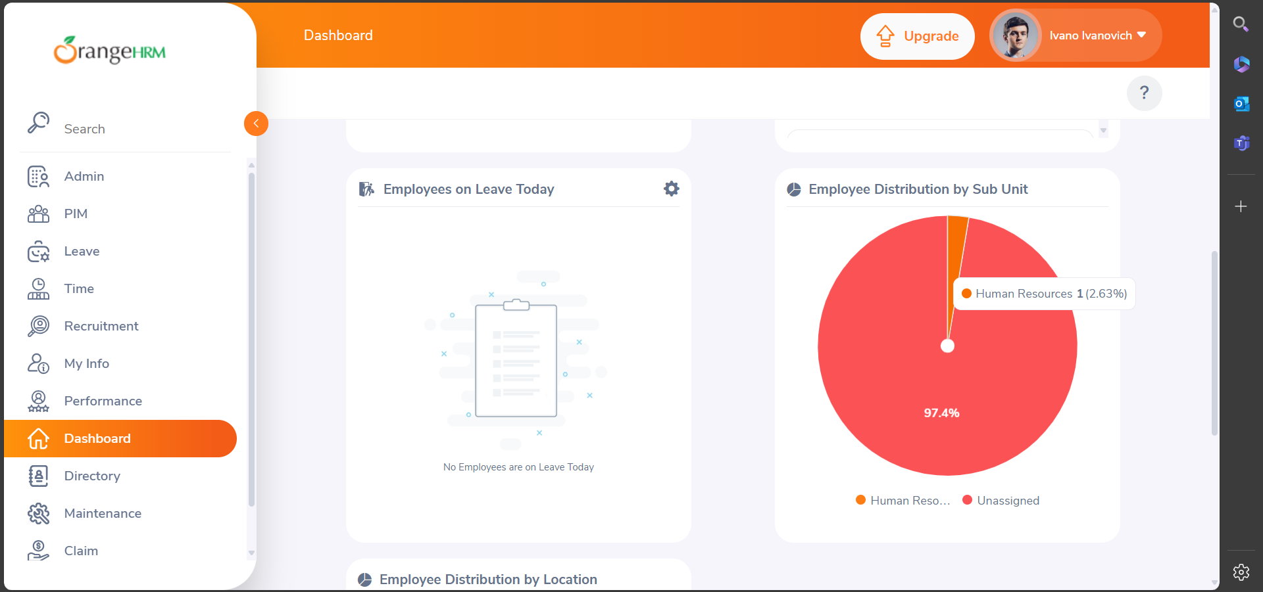

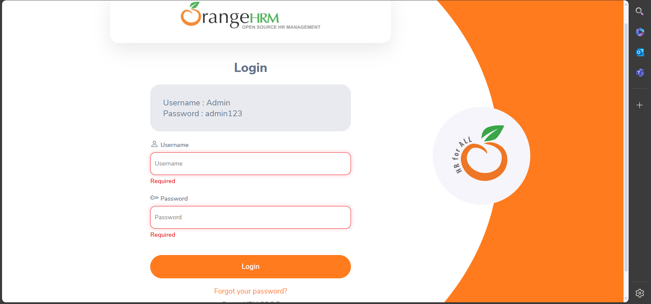

10. Create a Defect Report for each failed or blocked test case.

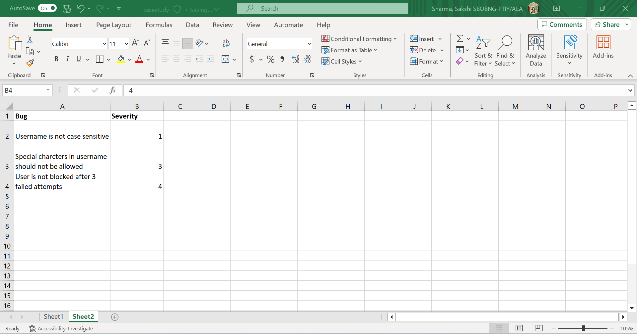

11. Create a new repository on your GitHub account

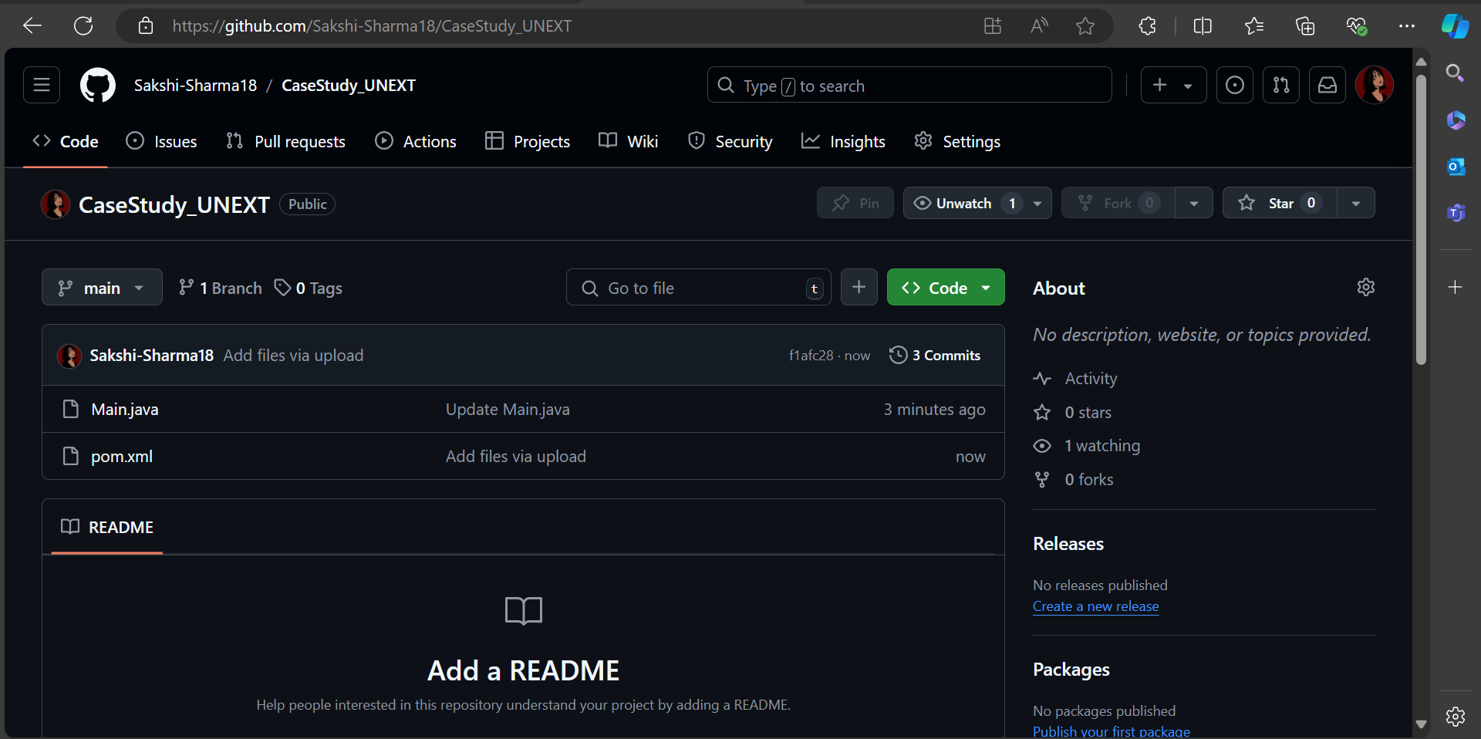

12. Clone the code base of the Java (any preferred language) project into your repository. The project’s codebase would be present in the VM.

13. Create a New Workflow on GitHub Actions for the Java/Maven code.

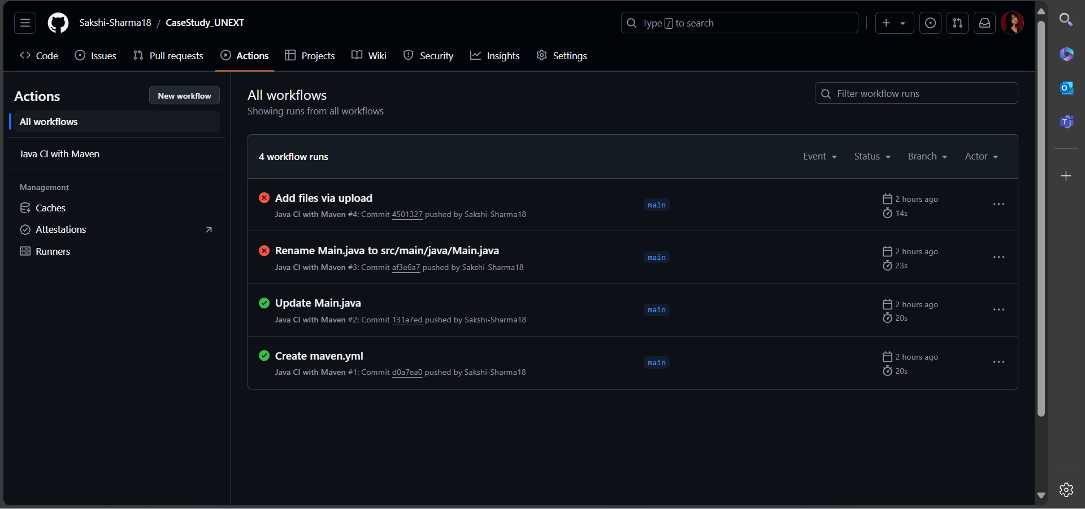

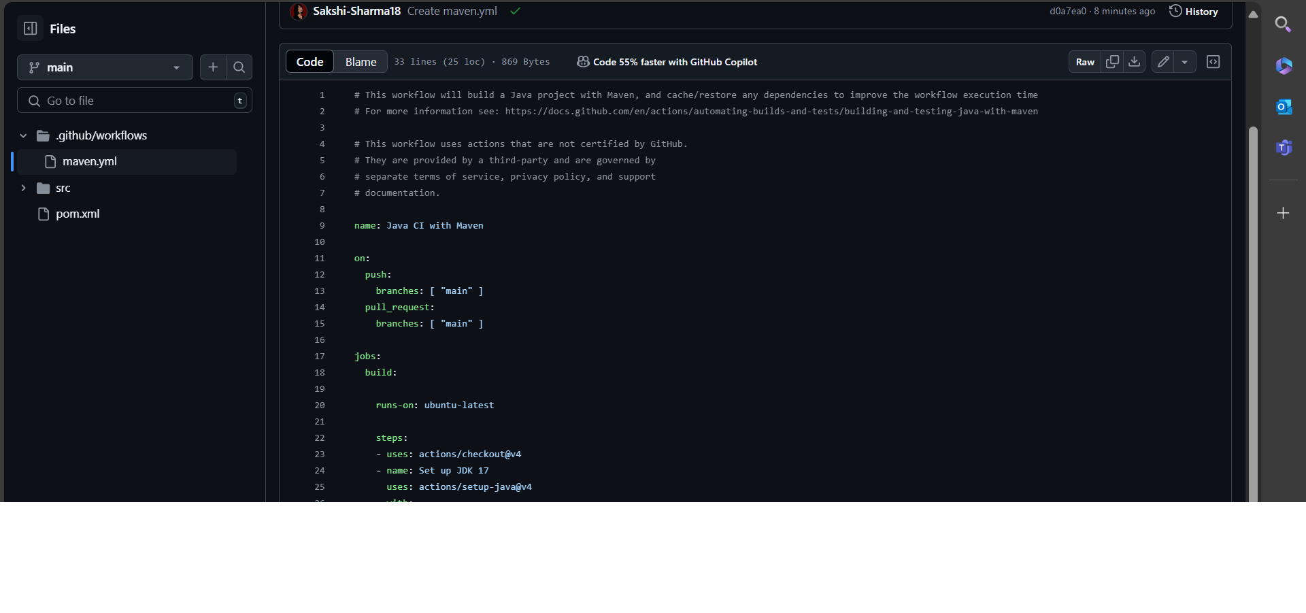

14. Monitor the created build

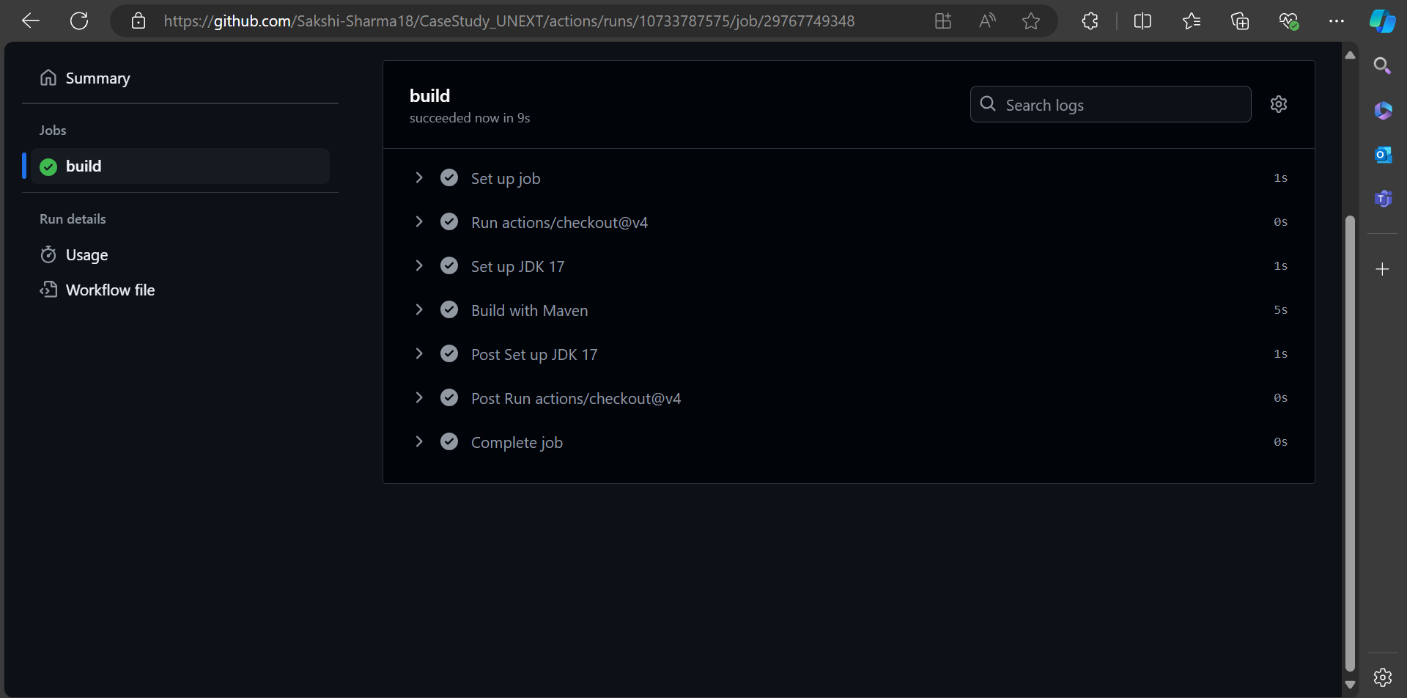

15. Modify the code in your repository to recheck the Workflow and the Build. For example, you could modify a Java class or update the pom.xml file.

Introduced errors to java code intentionally. Build will fail. Testing a failed build.

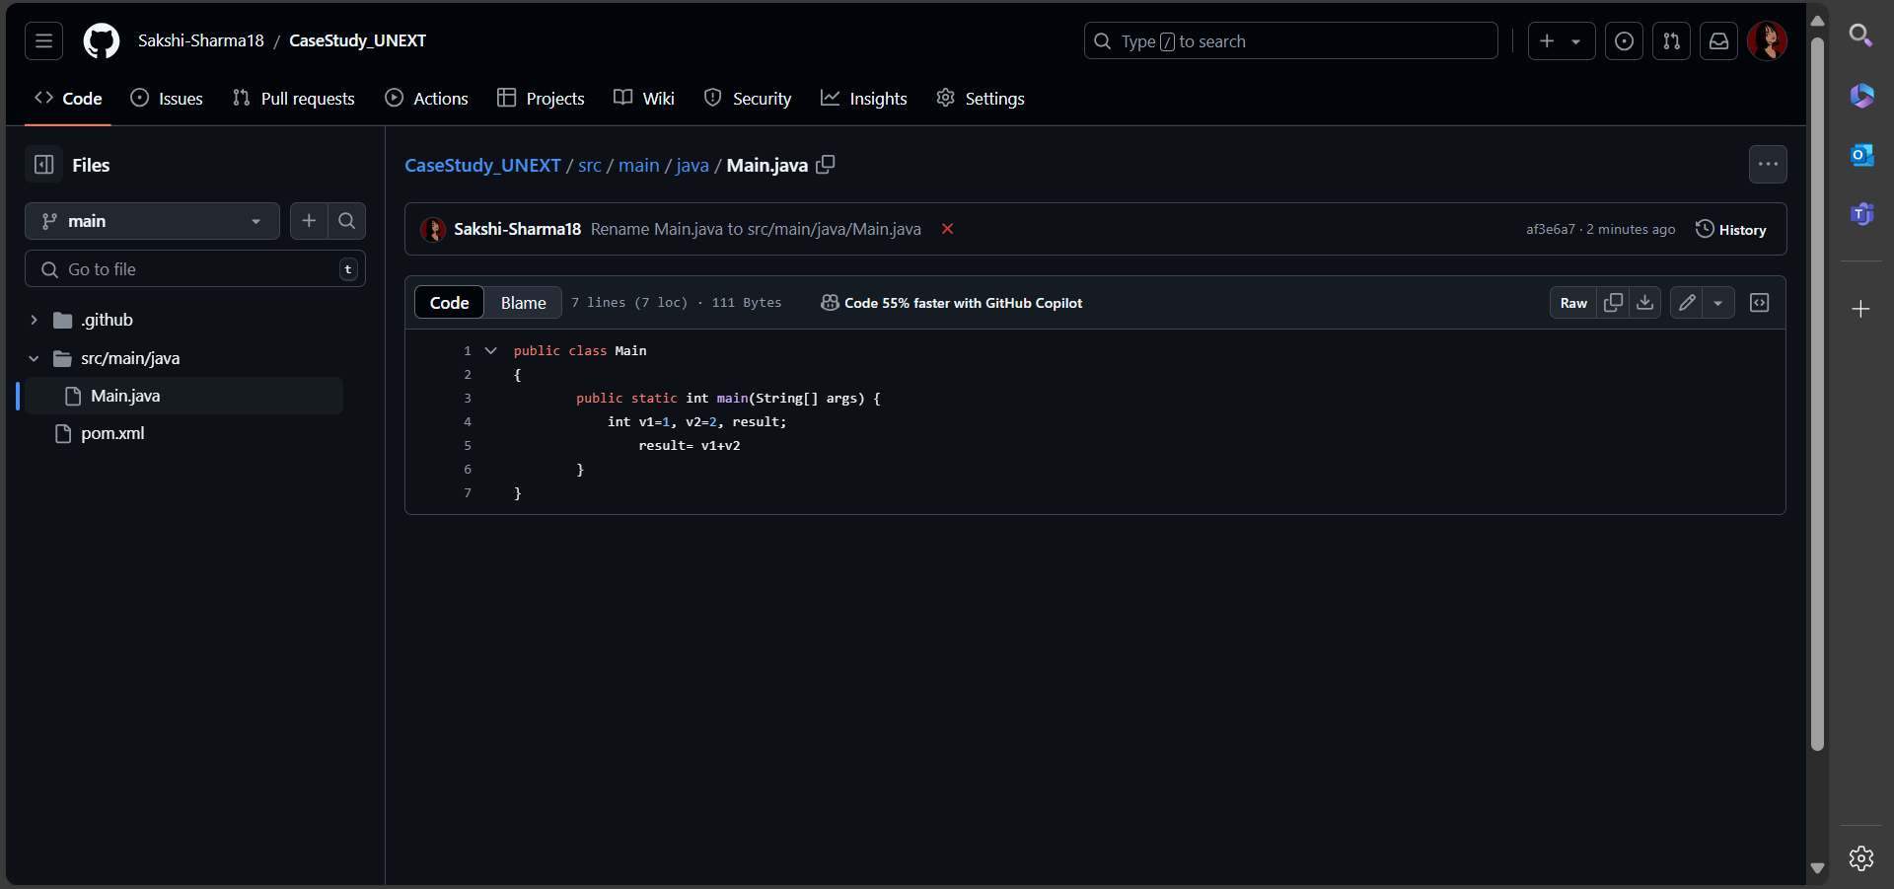

16. Commit it and monitor the build result

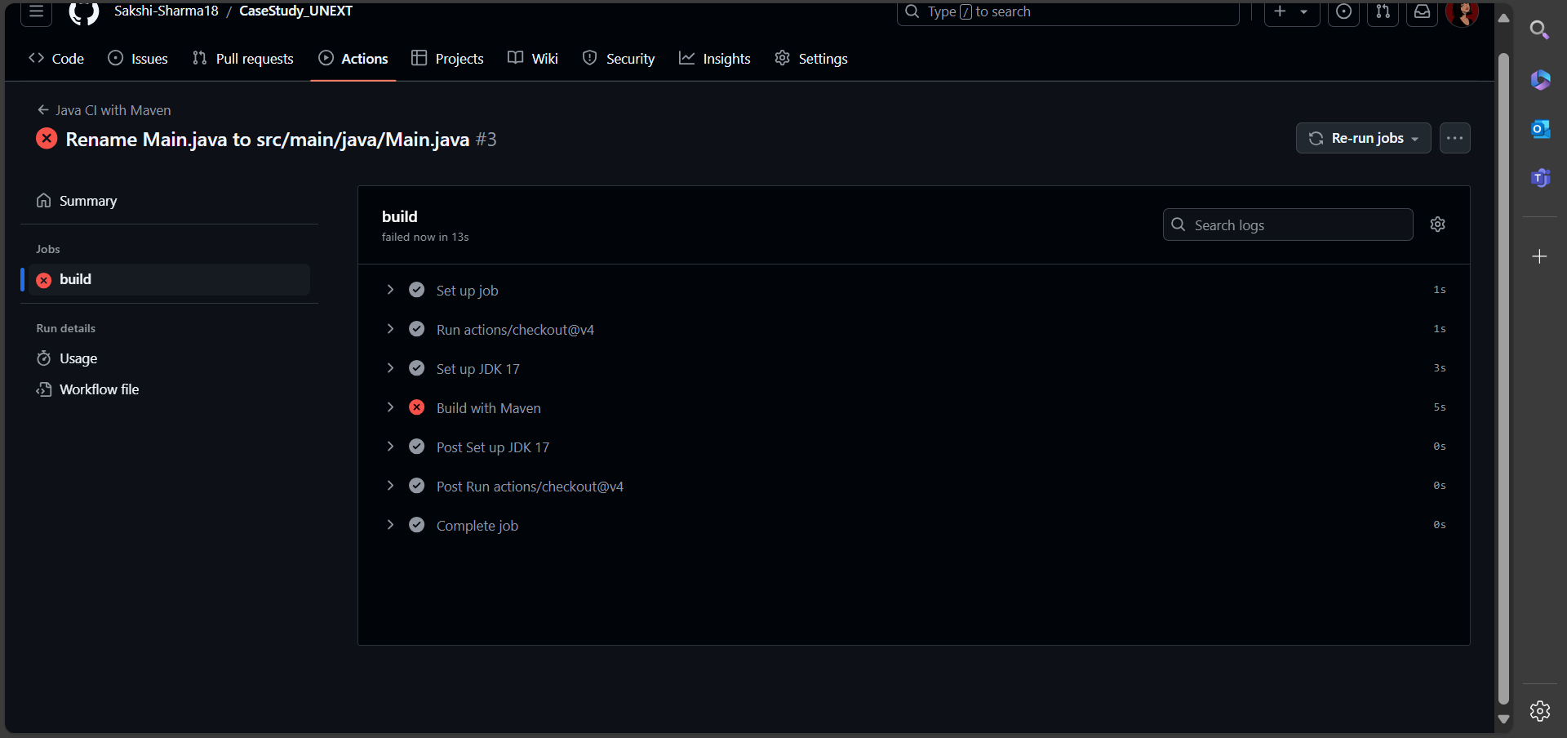

17. Update the screenshot of successful build and commit it in the repo.

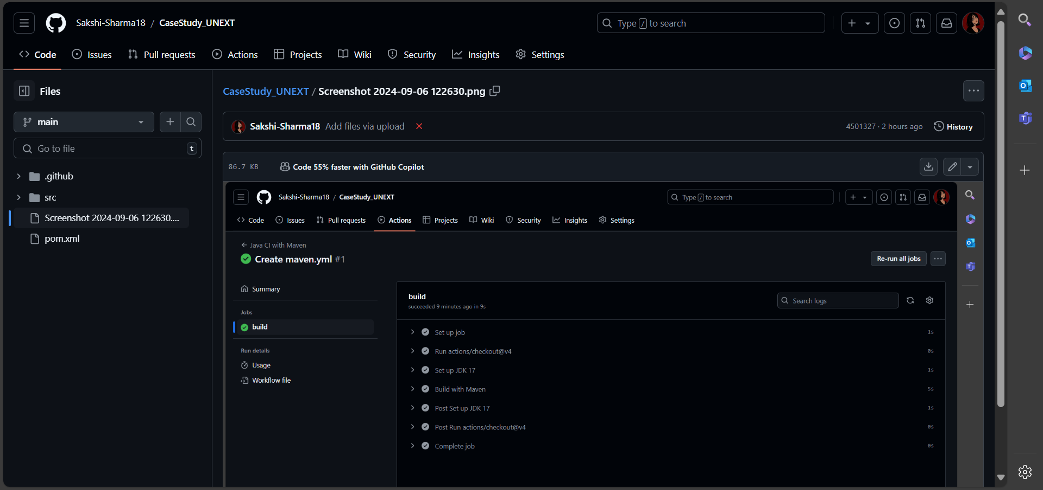

18. In your repository, add the created test cases report and defect report.

